Interactive Learning Platform Guide

Document Information

Author
Connor Forsyth, Solutions Analyst, ICT, Business Services

Revisions
Revision date | Summary of Changes
21/04/2020 | Document Creation

Description
This document contains a detailed description of the technologies used to create the learning platform and how to use each technology.
Contents
Interactive Learning Platform Guide 1
Document Information 1
Author 1
Revisions 1
Description 1
Github Classroom 2
What is Github Classroom 2
How to use it 2
Travis CI 3
GitChecker 4
Prerequisites: 4
How to use it 4
Stack Overflow Bot 6
Slack 6

Github Classroom

What is Github Classroom
GitHub Classroom is a teacher-facing tool to simplify the educational use of GitHub. Every student needs feedback and support as they learn to code, and using GitHub you can give them the right advice, in the right place, at the right time. Github Classroom allows you to create classes for every module you may instruct and within it have as many or as little assignments you want your students to complete.

How to use it
Invite Link: https://classroom.github.com/classrooms/51372470-test-driven-teaching-with-advanced-web-technologies-classroom-1
Using the invite link above, you can connect to the pre-existing classroom that has already been setup. Once you have joined you should be in the classroom backend and see something like that shown below.
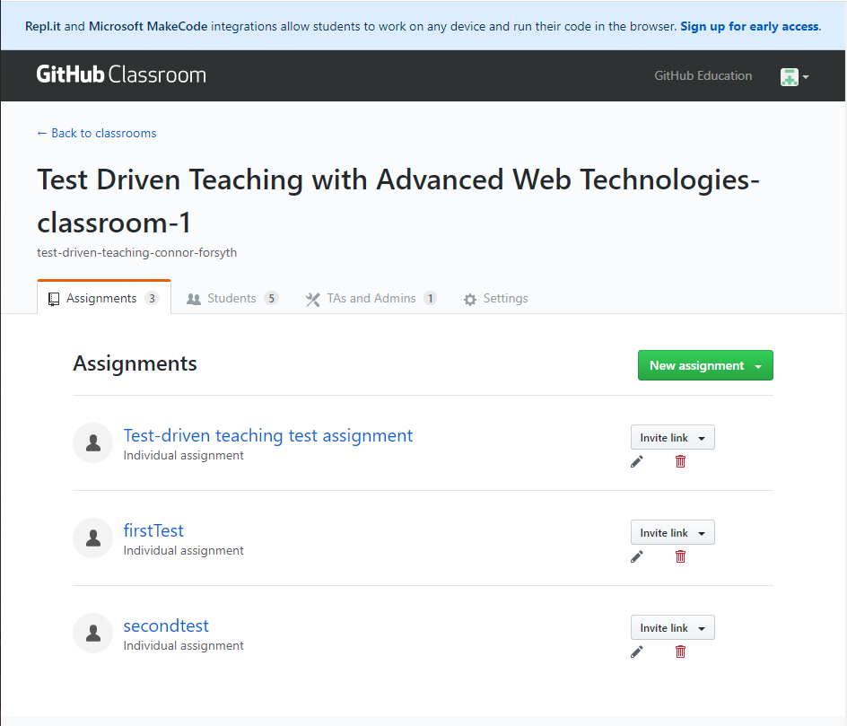
The assignment that this test is interested in is the Test-driven teaching test assignment, click on the link and we will be taken to the assignment page. Here we can see that currently there are five students who have either not accepted the assignment or have not linked their account to the Classroom yet.
If you are interested on setting up your own Github Classroom, Jacob Fiksel has setup an excellent guide on how to do so at: https://github.com/jfiksel/github-classroom-for-teachers

Travis CI
Whereas Github is used as a version control system, Travis CI is utilised in conjunction with the version control software to provide feedback on the changes that have been made to the student’s repositories. With each change made a test is ran by Travis Ci, that runs and compiles the code the student’s have written so that they can get instant feedback on the work they have carried out. A test can return one of two values, either a pass or a fail.
In the repositories, you will notice that they all contain three main files:
- A generic javascript file that contains the code
- A travis.yml file that contains the configuration settings that tells Travis what language the code is in
- A package.json file that contains the tests we want to carry out
Whenever changes are made in a repository, Github notifies Travis CI of the changes and the test is run against the code.
To access the Travis Ci tests, head over to a student’s repository and you will notice either a green tick or a red cross as shown below:
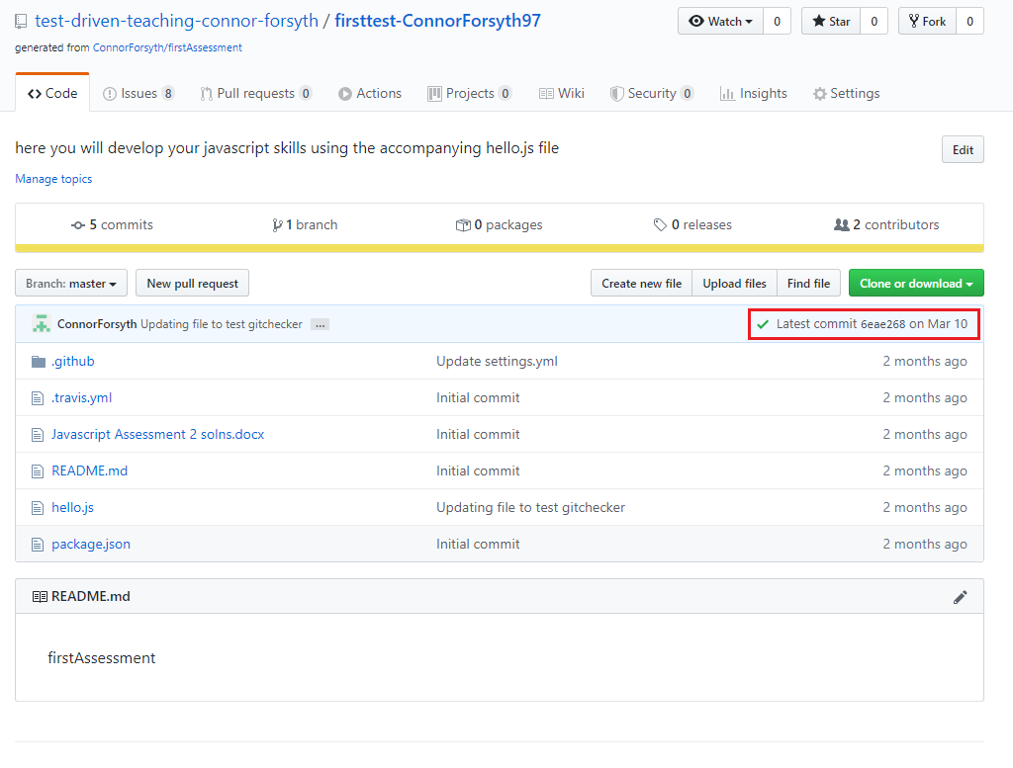
Click on the icon and a dialog will open, click the details button which will take you to the actions section of the repository and you should see something like this:
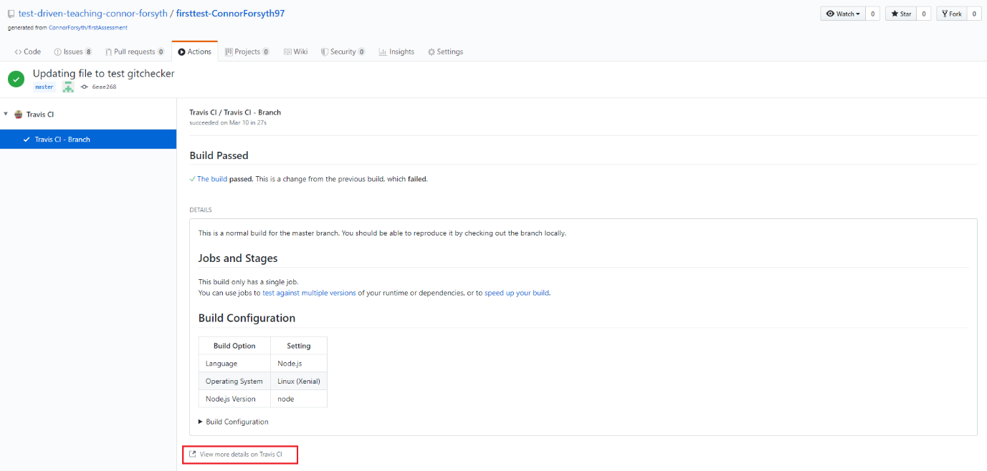
Clicking the view more details button will open a new tab in your browser and show the completed test. Scroll down the page and you will see the full output of the code run with any console logs displaying below.

GitChecker

Prerequisites:
Before you can use this application, you will need to ensure that you have node.js installed on your machine, if you haven’t done so already here is a link: https://nodejs.org/en/download/.

How to use it
The website that has been included as attachment with this guide, gives you the ability to monitor all the repositories in the organisation and how often the students have been deploying changes to their repositories as shown below. To start-up the website locally in your command prompt navigate to the website’s directory and enter the command npm start.
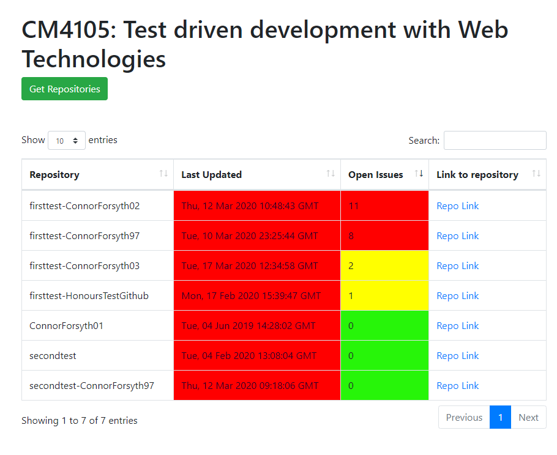
As you can see from the image above, the last updates and open issues fields both have a colour coded scheme. For the last updated field, the colours represent:
- Green – Last updated in the past week
- Yellow – Last updated between a week and 10 days ago
- Orange – Last updated between 11 and 14 days ago
- Red – Last updated over two weeks ago
For the Open Issues field:
- Green – 0 open issues
- Yellow – Less than 2 open issues
- Orange – 3 open issues
- Red – More than 4 open issues
If you want to view a specific assignment for example firsttest, all you need to do is type this into the provided text box and the table will automatically update accordingly as so:
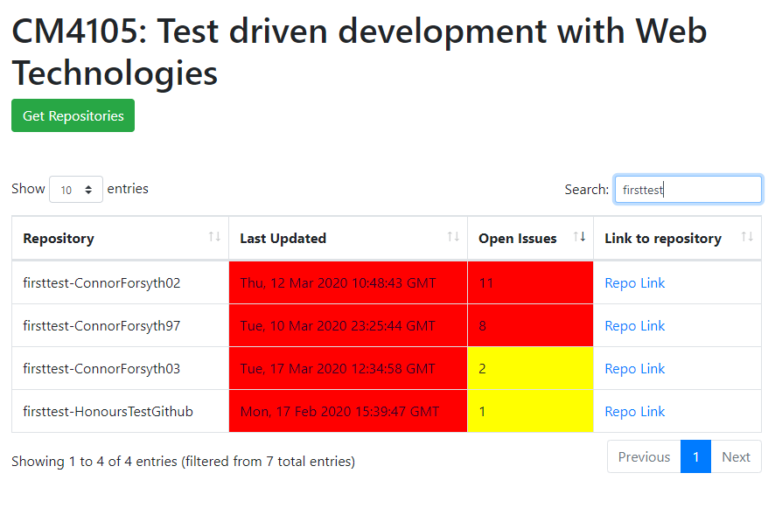
In future releases the project intends to develop a Github authentication process so that the site can load any organisations said user may be a part of. However, at this moment in time, the site only points to the test organisation.

Stack Overflow Bot
To help alleviate student questions on potentially easy to solve issues in their work, a bot built on the Github Probot infrastructure has been integrated into the organisation so that students can query the bot in their repositories to hopefully solve the issue they are having. Thus, allowing you to focus on resolving any significant issues that may be affecting your students.

Slack
Invite Link: https://join.slack.com/t/rguglobal/shared_invite/zt-e53tlks0-ZVU1n2mibwaGOAcUcIaBag
Whilst this assignment is set as an individual assessment, collaboration has been shown to be a major factor in learning to program. By introducing the students to a communication platform such as Slack not provides a platform for the students to collaborate in but provides them with experience in using such technology which will prove beneficial once the students graduate and go on to find work within the industry where such technology is standard.
The benefits for the students to use this platform is that it allows the students to discuss with one another about any issues or problems they are having. By troubleshooting their problems, students will improve upon their problem solving and communication skills which will prove vital once they graduate.
On top of providing a space for students to collaborate in, slack provides a simple integration with Github, that allows slack to monitor various events in repositories such as issues and comments. You will notice that there is a channel called helpwanted, within this channel any issues events that are tagged with the label help-wanted will be posted in here for the students to see, with the idea being that the students would be encouraged to help their fellow students. The command used to make this possible is as follows: /github subscribe test-driven-teaching-connor-forsyth comments +label:"help-wanted".
